**Delivery Day Layout**

**WHAT TO DO**

**COUNT & VERIFY YOUR ORDER WITH THE DRIVER**. After ensuring the order is 100% accurate, break down the pallet(s) by placing Kits under the corresponding Delivery Day Product Sign, hung up in the same order as the order form. Stack the Kits 10 high with color label facing out.

**Use your Brochure Order Forms to fill orders and organize by seller’s last name in alphabetical order.**

* Don’t forget to print your online orders! Login at [PizzaKit.com](https://www.pizzakit.com) to *View & Print Online Orders* for sorting at delivery. NOTE: Online orders are not differentiated from brochures orders at delivery or on the invoice.
* Double check all orders for accuracy before pick-up
* Allow at least one hour to sort before parents begin picking up orders.

**Ask parents to sign the order form/tally sheet before they leave, agreeing that the order was complete and accurate.**

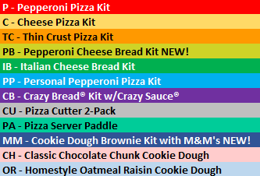

🚹

Exit Here

🚹

**Last Name M-R**

**Seller 1**

Kits and Cookie Dough Order

🚹

**Last Name A-F**

**Seller 1**

Kits and Cookie Dough Order

🚹

Check-In Table

M - Z

🚹

🚹

**Last Name S-Z**

**Seller 1**

Kits and Cookie Dough Order

**Last Name G-L**

**Seller 1**

Kits and Cookie Dough Order

Check-In Table

A - L

We recommend (one) 1 helper/volunteer per 100 items sold!

***Questions?*** We’re here to help!  
1-888-452-5487 or [service@PizzaKit.com](mailto:service@PizzaKit.com)   
Monday – Friday 8:30am to 6:00pm ET  
(Product listing shown may vary by season.)