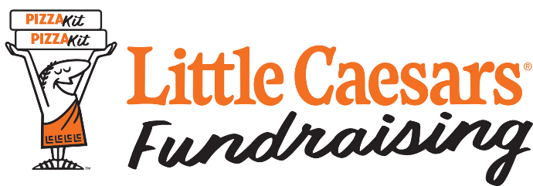

**Delivery Date Reminder Notice**

Dear Parents/Members,

Our Little Caesars® Fundraiser order will be delivered on

Date ___________________________________

Pick Up Time ___________________________________

Location ___________________________________

Reminders:

* **All items must be picked up on this day. We do not have storage and will not be able to hold your Kits overnight.**
* **Kits arrive frozen so immediate delivery of the Kits to your customers is recommended.**
* Your child will need help delivering products to his/her customers.

If you have any questions, please free to call me at # (_______)_______- ______________.

Thank you for a great fundraiser!

Your continued support is very much appreciated.

________________________________________  
 (Chairperson’s Name)

P.S. It’s a good idea to call your supporters 1-2 days in advance to ensure that they’ll be available to receive their orders.